- Biology
Virtual Photosynthesis Elodea Inquiry

google presentation to help for this project
Rubric for Criterion B: Inquiring and Designing - Bio S1

Title of Experiment: Light color

AST 8.1 Formulate the Question
Based on observations and science principles, I can formulate a question or hypothesis that can be investigated through the collection and analysis of relevant information.
Factor we will investigate: _light intensity_________
Wild Guess Question: _what is the effect of light intensity on the rate of potosynthesis_________
Wild Guess: ______________ light intensity lowers and slows down the rate of photosynthesis__________.
Research Question: _to investigate effect of light intensity on rate of potosynthesis_________
Background Information:
Write a background information section that communicates:

Photosynthesis is the process by which plants, and some bacteria, use solar energy to produce sugar. This process converts light energy to chemical energy, which is stored in the sugars. The reactants for photosynthesis are light energy, water, carbon dioxide and chlorophyll, while the products are glucose (sugar), oxygen and water. Light from the sun, molecules of carbon dioxide from the air, and water molecules from their environment and combine these reactants to produce food (glucose). The products, oxygen is useful to the other plants and animals for respiration while glucose is a source of energy for plants and animals. In plants, chlorophyll a and chlorophyll b are the main photosynthetic pigments. Chlorophyll molecules absorb blue and red wavelengths and the green pigment reflects the green light. During photosynthesis, plants absorb carbon dioxide and sunlight to create fuel—glucose and other sugars—for building plant structures. This process forms the foundation of the fast (biological) carbon cycle. This process of photosynthesis is important for two reasons. First, photosynthesis provides the energy that is used by all other organisms to survive. Second, photosynthesis removes carbon dioxide from the atmosphere, replacing it with life-sustaining oxygen.

- The products and reactants of (molecules required and produced from) photosynthesis
- Where do the reactants of photosynthesis come from?
- What are the products of photosynthesis used for? (Think back to Unit 2 - Biomolecules.)
- How is light absorbed and reflected by different molecules?
- How does photosynthesis fit into the carbon cycle?
- Why is photosynthesis an important process for Earth’s systems?
***In your background information, you will need to summarize these findings IN YOUR OWN WORDS. Since the ideas you will include are not your own, you will need to cite your sources using in-text citations and create a works cited list in APA format (not just include the links). Citation Machine is a good tool for this - but Google Docs now has a Citation maker! Find it under the Tools menu. Alternate citation resource: Cite This For Me
Use the following sentence frames or write your own.
According to my research, __________
_______ is known to _________
According to _________, studies have shown _______.
Additionally, ______

Variables:
Our independent variable is _ distance from the light source/light intensity._ and our dependent variable is __ the number of bubbles produced per minute. ___. 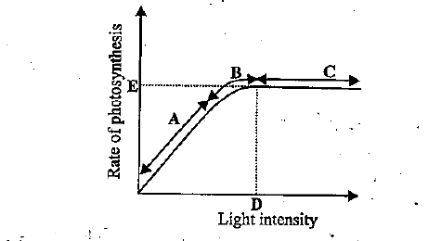

Null Hypothesis (H₀): ____7

Alternate Hypothesis/Mathematical Prediction (H_{A}):
Double-click on the set of axes to open the Google Drawing tool and draw a line that shows what you think the trend of photosynthesis will be as your independent variable increases. Label the axes on your graph!

What kind of mathematical model describes the line that you drew? Identify the model and justify your choice.
___the graph will likely follow a ____curve_____ pattern because __increase in light intensity leads to increase in rate of photosynthesis_______.

Controlled Variables, with Values:
We will control the following variables at the described levels:
- ____ distance from the light source/light intensity ___ will be controlled by ___moving the light source to and from the plant______
- ___number of bubbles produced____ will be a kept at a constant level of _maintaining constant tempeature _____

Introduction Checklist Do you have:
- Research Question | - Background information about photosynthesis (in general) and your independent variable?
- Null hypothesis (in words) and alternative hypothesis (in words and in pictures) | - Controlled variables listed, along with their measured values?

AST 8.2 Experimental Design
I can design and conduct a controlled experiment, field study, or other investigation to make systematic observations about the natural world, including the collection of sufficient and appropriate data

Notes on how to use the simulation:
- Go to this website and watch two short videos: “How to use the photosynthesis simulation” and “How the photosynthesis simulation works”.
- Open the Photosynthesis Processing Sketch and use “Select All” (Ctrl-A) to copy the ENTIRE code (about 20 pages of text).
- Open Openprocessing.
  - DELETE any code that appears in the window and then paste (Ctrl-V) the ENTIRE code of the Photosynthesis Processing Sketch.
  - In the upper right-hand corner under Mode, select Pjs.
- To start your simulation, click on the play button on the center top of the screen. This will run the simulation with whatever conditions are dictated by the code you pasted.
- To modify the code, click the </> button (at the top near the play button). The directions for changing the code are described at the top of the page.
- Don’t, ever, click SAVE! This will mess up all the future trials.
- Be aware: all trials are 30 seconds long.

Procedure: Now that you know the basics about how to run the virtual experiment, you must write a detailed step-by-step procedure that details how you perform your investigation to address your specific variable and question. Include how you will change your independent variable (________), how you will measure your dependent variable (_________), and how your experiment will be controlled.

The procedure may be written in a step-by-step numbered list or in a paragraph. You will likely include diagrams or screenshots to help clarify the procedure. You may refer to the “Notes on how to use the simulation” included above rather than rewriting them.

Use the Methods review checklist
to make sure that your Methods section has all the required components. Need help? Look at some sample procedures that indicate the level of detail you should be including.
Write your procedure here.
The effect of light intensity on photosynthesis can be investigated in water plants. Use Cabomba or Elodea, which are sold in aquarium shops.
The plants will release bubbles of oxygen - a product of photosynthesis - which can be counted.
A lamp with an LED bulb is set up at different distances from the plant in a beaker of water.
- An LED bulb is best as this will not raise the temperature of the water.
- Sodium hydrogen carbonate - formula NaHCO₃ - is added to the water to supply carbon dioxide - a reactant in photosynthesis - to the plant.
- The light intensity is proportional to distance - it will decrease as the distance between the bulb and the plant increases - so light intensity for the investigation can be varied by changing the distance from the lamp to the plant.
The bubbles produced over one minute periods are recorded.

Aim
To investigate the effect of light intensity on the rate of photosynthesis.

Method
- Set up a boiling tube containing 45 cm³ of sodium hydrogen carbonate solution (1%). Allow the tube to stand for a few minutes and shake to disperse any air bubbles that might form.
- Cut a piece of the pond weed, Cabomba. The pond weed should be 8 cm long.
- Use forceps to place the pond weed in the boiling tube carefully. The pond weed should be put in boiling tube, with the cut end uppermost. Make sure that you don’t damage the pond weed, or cause the liquid to overflow.
- Position the boiling tube so that the pond weed is 10 cm away from the light source. Allow the boiling tube to stand for five minutes for the pond weed to acclimatize. Count the number of bubbles emerging from the cut end of the stems in one minute. Repeat the count five times and record your results.
- Calculate the average number of bubbles produced per minute. Repeat the experiment at different distances away from the light source.

Variables
- Independent variable - distance from the light source/light intensity.
- Dependent variable - the number of bubbles produced per minute.
- Control variables - concentration of sodium hydrogen carbonate solution, temperature, using the same piece of Cabomba pond weed each time.

Procedure/Methods Section Checklist Do you have:
- Picture(s) / drawing(s) of your experimental setup? | - Detailed procedure, including specifics about all the steps you will do?

AST 8.3 Collect and Present Data
I can collect, organize, and display sufficient and appropriate data to facilitate scientific analysis and interpretation.
Methods review checklist

Qualitative Data (Observations) on the simulation, code, or the process of using them:
(Note: don’t include observations about the trend you observe in the data here)
When ______, ______.
As

Quantitative Data: (Note: you may not need all the rows in the table, and you may need to add more)
Working with the carbon dioxide or light intensity variables? Use the table below.
IV: ______ (units) +/- 1 | DV: ______________ (units) +/- 1 |  |  | Average DV:_______ (units)
IV: ______ (units) +/- 1 | Trial 1 | Trial 2 | Trial 3 | Average DV:_______ (units)

Working with the color variable? Use this Google Sheet to enter your data, calculate the average and standard deviation, and graph. When you are done, copy and paste the completed table from Sheets into this document (and delete the table above).

Graphing:
- Make a graph appropriate to your data.

Working with the carbon dioxide or light intensity variables?
Graph your average data in Desmos by:
- Using this template
OR
- Teacher Desmos Link provided by your teacher :
P1 Nuss Teacher.Desmos | P2 Nuss Teacher.Desmos | P3 Mills Teacher.Desmos | P3 Denis Teacher.Desmos

Use the Desmos scatter plot and determine which of the mathematical models produces a best-fit trendline (or trendlines) that hit as many points as possible, through the error bars. You may end up with more than one!
Working with the color variable? Use Google Sheets to make your graph. Think about what kind of graph is most appropriate for the data you have collected. If you need a tutorial for graphing in Google Sheets, click here.

- Insert your graph and equation(s) below, and answer the basic analysis questions.
Insert a screenshot of your group’s computer graph here. If applicable, include the equation(s) that describe your best fit line! In your equation, make sure to use your IV and “Number of O₂ Bubbles” instead of x and y.
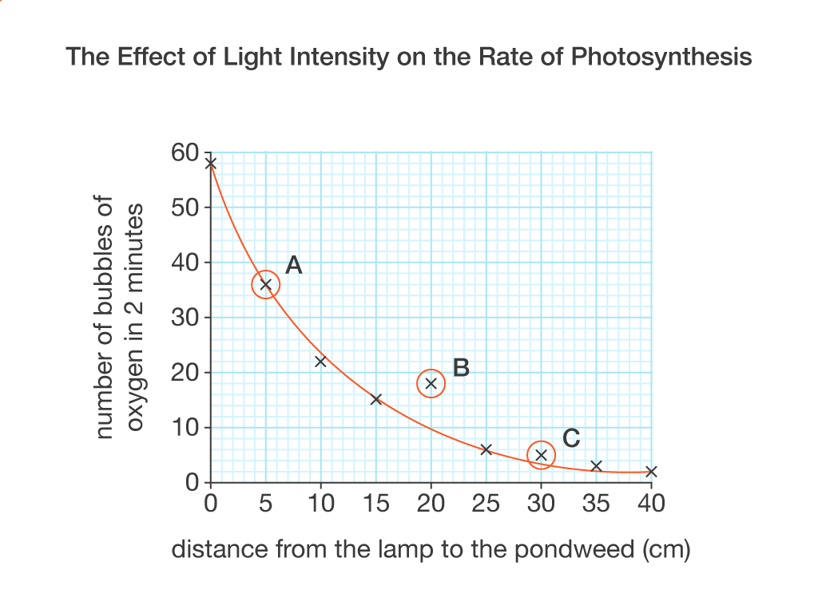
Analyze your graph. Fill this information out here and include it in your conclusion!
- The equation of the best-fit line is _______________, and the mathematical pattern is _________________.
- This trend is visible from _______________ to _______________.
- The slope of the line is _______________ and means _______________.

(If your graph has a second trendline, include the information here.)
- The equation of the best-fit line is _______________, and the mathematical pattern is _________________.
- This trend is visible from _______________ to _______________.
- The slope of the line is _______is an inverted curve________ and means _______________.
That increase in distance leads to decrease in number of bubbles produced per minutea
What does the y-intercept (if there is one) tell you? (Be specific and include a number!)
The y-intercept is _____n/a__ and shows _______.
What, generally, does your graph tell you? (Summarize your data.)
The graph shows that ... this graph shows that the number of bubbles produced decreases with increase in distance of the lampstand from the plant. This means that the increased light intensity increases the rate of photosynthesis

- Add your graph to your class Virtual Photosynthesis Data Sharing slideshow for your class.
Period 1 Nuss | Period 2 Nuss | Period 3 Denis | Period 3 Mills

Include the following information on your slide:
- What is the rate of increase in photosynthesis for your IV?
- For how long did the increase occur?
- If your IV resulted in a maximum rate of photosynthesis, what is it?
- What do these results imply about the maximum efficiency of photosynthesis? (With luck, the answer to this question will agree with your background information!)
- Do you expect the increase would continue forever? What are the potential limits?
- How confident are you in your data set, and why? (This should match the information from the confidence chart, or provide additional reasoning.)
- Make a new data-informed prediction based on the class results. Ask yourself the Wild Guess Question again, and answer it using your graph and/or equation.
Using the data, the optimal environment for ______photosynthesis________________ is ___________________medium to high intensity__.

Data Section Checklist Do you have:
- Units and uncertainties in your data table? | - Best fit line(s) on your graph?
- Labeled x- and y- axes on your graph? | - Error bars that you can make sense of?
- A completed slide in the Data Sharing Slideshow? | - One (or more) equation(s) written in terms of the variables?

Conclusion: Write a conclusion that answers your research question

AST 8.4 Analyzing and Interpreting Results
Summarizes and analyzes data to draw a valid and supported conclusion to communicate the findings of an investigation, and identify uncertainties.
MYP Criterion C Rubric - Processing and Evaluating
Conclusion: Write a conclusion that answers your Research Question. Use the drafting tool below to help you.
Claim/Evidence  - What claim are you trying to make? (Go back to the RESEARCH QUESTION.)  - What evidence (data) do you have to support your claim?  - State your claim  - Provide evidence that supports the claim (mathematical model(s), shape of graph, meaning of mathematical model, data points, meaning of the constant, other evidence)  Possible Sentence Starters  According to the data, ... This suggests that …  This experiment determined that … The data that supports this claim is/are …  Since the data suggests ___, I conclude that …  The evidence strongly suggests that … The data bolsters this position because …  The mathematical model that best fits the data is ___, and represents a ___ pattern. | Draft of Claim Section  According to this data, increase in light intensity increases the rate of photosynthesis. This is due to the inverted curve line that shows that increase in distance decreases the number of bubbles produced per minute by an aqueous plant
Reasoning  - What scientific concepts from your background research support this evidence?  - Provide scientific justification that ties your evidence and claim together (use your background information to guide you)  - Your reasoning should explain why the photosynthesis rate changes observed with your independent variable make sense in terms of what you know about how cells function to produce glucose.  Possible Sentence Starters  ___ occurred due to …  The data can be explained by …  ___ is related to ___ because …  These results can be understood by thinking about …  Word Bank: | Draft of Reasoning Section  More light is absorbed by the chloroplasts which break down water faster releasing more oxygen thus more bubbles
  photosynthesis | chloroplast | Light | carbon dioxide (CO₂) | oxygen (O₂)
  glucose | plant | Intensity | color
Prediction and Confidence in Prediction  - Make your data-informed prediction: what are the best conditions for photosynthesis?  - Determine your confidence using the confidence chart:  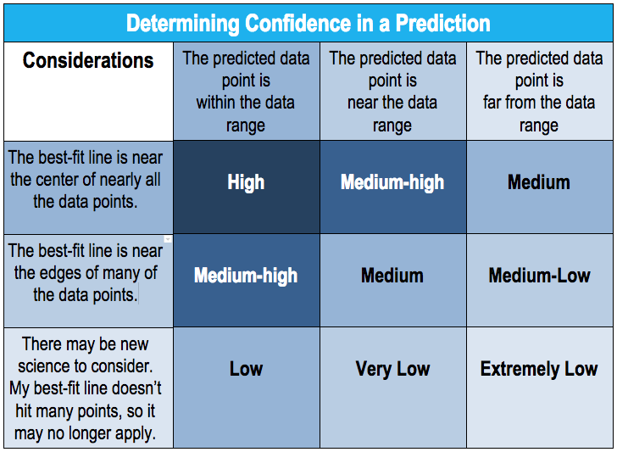  Possible Sentence Starters  With ___ confidence, I predict that … I have ___ confidence because …  Based on my data, the best conditions for photosynthesis are … The certainty of my prediction is ___ due to …  The model predicts that … Due to ___, the confidence in this prediction is …  Cardiovascular homeostasis is reached when …  Doing ___ for 65 seconds is/is not sufficient for ___ because … | Draft of Prediction Section  With more confidence, I can predict that the ideal environment for photosynthesis is medium to high light intensity areas
Limitations  - Does the mathematical model always apply or are there situations where it breaks down?  - Discuss whether the trend or mathematical model always applies or whether there are situations where it breaks down.  - Describe any uncontrolled factors that may have influenced the accuracy or validity of your data and how they may have influenced your results.  Possible Sentence Starters  ___ applies when …  It was difficult to control for ___ because …  ___ may have affected the results by … | Draft of Limitations Section  The situation does not break down
Implications for Climate Change:  - What are the implications for climate change ?  - Why do we need to understand about the things that affect photosynthesis?  - How are the results generated here important for considering photosynthesis’ role in the carbon cycle and long term climate questions?  Possible Sentence Starters  ___ should be considered as part of ___ because …  Due to ___, people should consider …  ___ is an essential ___ because...  Clearly ___ and as a result, …  I would/would not ___ because … | Draft of Implications Section  I would propose that climate change be curbed since high temperatures will reduced the rates of photosynthesis increasing the amount of carbon (iv) oxide.
Extension/Application  What is a connection you can make between what you learned in this investigation to everyday life?  –AND / OR –  What is a new testable question you have that extends the knowledge of this investigation?  - Connect your learning to a real-world scenario.  –AND / OR –  - Write a thoughtful, testable research question that is related to the experiment you have just completed, but that would provide additional insight.  Possible Sentence Starters  Building on these findings, another question that could be investigated is …  Future work in this area that could be investigated is …  -OR-  A real-world connection to this experiment is …  The knowledge gained in this experiment connects to ___ because... | Draft of Extension Section  Building on these findings plants should be kept in the open to access more light.
When you have finished drafting and editing in the table, write your final draft here, in paragraph form:
According to this data, increase in light intensity increases the rate of photosynthesis. This is due to the inverted curve line that shows that increase in distance decreases the number of bubbles produced per minute by an aqueous plant. More light is absorbed by the chloroplasts which break down water faster releasing more oxygen thus more bubbles. With more confidence, I can predict that the ideal environment for photosynthesis is medium to high light intensity areas. I would propose that climate change be curbed since high temperatures will reduced the rates of photosynthesis increasing the amount of carbon (IV) oxide. Building on these findings plants should be kept in the open to access more light

Conclusion Checklist Do you have:
- Conclusion complete with all the parts? | - Have you checked the rubric to make sure your work meets expectations?

For additional assistance, see the Resource Sheet for Writing Conclusions in Biology

